**EMPATHY MAP**

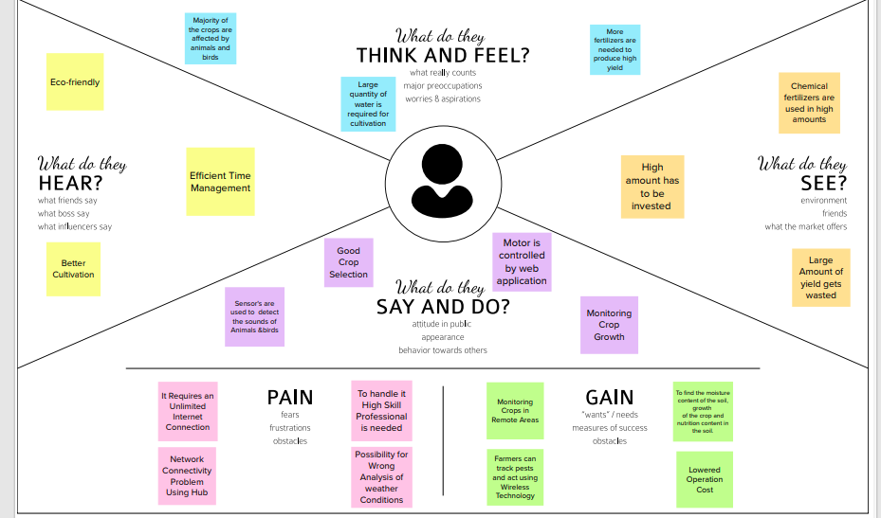

**PROBLEM STATEMENT**

To provide efficient decision support system using wireless sensor network which handle different activities of farm and gives useful information related to farm. Information related to Soil moisture, Temperature and Humidity content. Due to the weather condition, water level increasing Farmers get lot of distractions which is not good for Agriculture. Water level is managed by farmers in both Automatic/Manual using that mobile application. It will make more comfortable to farmers. Performing agriculture is very much time consuming.

**BRAINSTROMING IDEAS:**

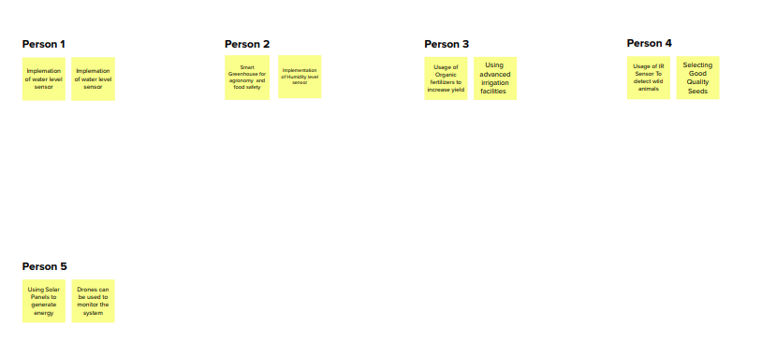

**ABSTRACT:**

Agriculture is the backbone of our country that contributes to 45% of the GDP that is responsible for the enhancement of country's economy. This IOT based Crop Protection System aims on building an integrated module for improving the efficiency of the present agricultural modules. A smart way of automating farming process can be called as Smart Agriculture. Precision agriculture is one of the most famous applications of loT in the agricultural sector and numerous organizations are leveraging this technique around the world. By implying an automated system, it possible to eliminate threats to the crops by reducing the human intervention. The major emphasize will be on providing favourable atmosphere for plants. These agricultural automated systems will help in managing and maintain safe environment especially the agricultural areas. Environment real time. Monitoring is an important factor in smart farming. Graphical User Interface based software will be provided to control the hardware system and the system will be entirely isolated environment, equipped with sensors like temperature sensor, humidity sensor. The I controllers will be managed by a master station which will communicate with the human interactive software. This IOT based system will provide smart interface to the farmers and can increase the level of production than the current scenario.

**LITERATURE REVIEW**

**Zuraida Muhammad, Muhammad Azri Asyraf Mohd Hafez, Nor Adni MatLeh, Zakiah Mohd Yusoff , Shabinar Abd Hamid [1]** The term "Internet of Things" refers to the connection of objects, equipment, vehicles, and other electronic devices to a network for the purpose of data exchange (IoT). The Internet of Things (IoT) is increasingly being utilised to connect objects and collect data. As a result, the Internet of Things' use in agriculture is crucial. The idea behind the project is to create a smart agriculture system that is connected to the internet of things. The technology is combined with an irrigation system to deal with Malaysia's variable weather. This system's microcontroller is a Raspberry Pi 4 Model B. The temperature and humidity in the surrounding region, as well as the moisture level of the soil, are monitored using the DHT22 and soil moisture sensor. The data will be available on both a smartphone and a computer.  As a result, Internet of Things (IoT) and Raspberry Pi-based Smart Agriculture Systems have a significant impact on how farmers work. It will have a good impact on agricultural productivity as well. In Malaysia, employing IoT-based irrigation systems saves roughly 24.44 percent per year when compared to traditional irrigation systems. This would save money on labour expenditures while also preventing water waste in daily needs.

**Divya J., Divya M.,Janani V. [2]**Agriculture is essential to India's economy and people's survival. The purpose of this project is to create an embedded-based soil monitoring and irrigation system that will reduce manual field monitoring and provide information via a mobile app. The method is intended to help farmers increase their agricultural output. A pH sensor, a temperature sensor, and a humidity sensor are among the tools used to examine the soil. Based on the findings, farmers may plant the best crop for the land. The sensor data is sent to the field manager through Wi-Fi, and the crop advice is created with the help of the mobile app. When the soil temperature is high, an automatic watering system is used. The crop image is gathered and forwarded to the field manager for pesticide advice.

**H.G.C.R. Laksiri, H.A.C. Dharmagunawardhana, J.V. Wijayakulasooriya [3]**Development of an effective loT-based smart irrigation system is also a crucial demand for farmers in the field of agriculture. This research develops a low-cost, weather-based smart watering system. To begin, an effective drip irrigation system must be devised that can automatically regulate water flow to plants based on soil moisture levels. Then, to make this water-saving irrigation system even more efficient, an IoT-based communication feature is added, allowing a remote user to monitor soil moisture conditions and manually adjust water flow. The system also includes temperature, humidity, and rain drop sensors, which have been updated to allow remote monitoring of these parameters through the internet. In real time, these field weather variables are stored in a remote database. Finally, based on the present weather conditions, a weather prediction algorithm is employed to manage water distribution. Farmers would be able to irrigate their crops more efficiently with the proposed smart irrigation system.